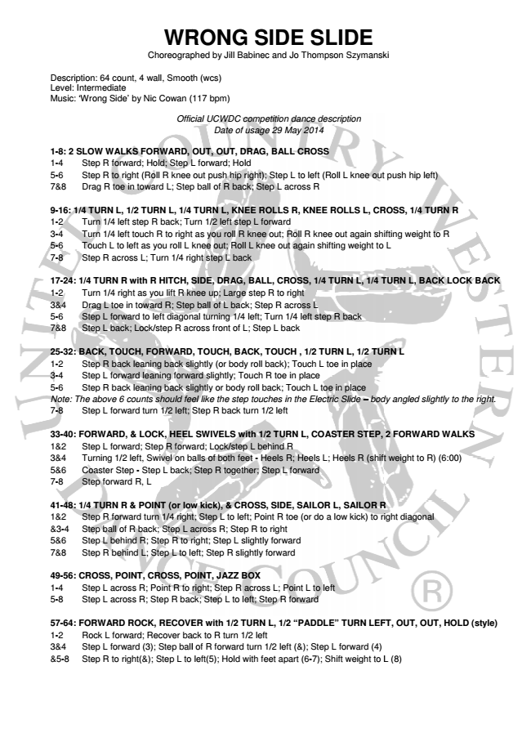
WRONG WRONG SIDE SIDE
SLIDE Choreographed Choreographed by by
Jill Babinec and Jo Thompson Szymanski
Description: 64 count, 4 wall, Smooth Smooth (wcs) (wcs) Level: Intermediate Music: ‘Wrong Side’ by Nic Cowan (117 (
bpm)
Official Official UCWDC UCWDC
competition dance description Date of usage 29 May 2014
1-8: 2 SLOW WALKS FORWARD, RWARD, OUT, OUT, OUT, OUT,
DRAG, BALL CROSS 1-4 Step R forward; Hold; old; Step Step L L forward; forward; Hold
H 5-6 Step R to right (Roll oll R R knee knee out out push push hip hip
right); Step L to left (Roll L knee out push hip le 7&8 Drag R toe in toward ard L; L; Step Step ball ball of of R R back; b
Step L across R
9-16: 1/4 TURN L, 1/2 TURN RN L, L, 1/4 1/4 TURN TURN L, L, KNEE K
ROLLS R, KNEE ROLLS L, CROSS, 1/4 T 1-2 Turn 1/4 left step R R back; back; Turn Turn 1/2 1/2 left left step s
L forward 3-4 Turn 1/4 left touch h R R to to right right as as you you roll roll
R knee out; Roll R knee out again shifting weight 5-6 Touch L to left as you you roll roll L L knee knee out; out; Roll R
L knee out again shifting weight to L 7-8 Step R across L; Turn Turn 1/4 1/4 right right step step L L back
b
17-24: 1/4 TURN R with R R HITCH, HITCH, SIDE, SIDE, DRAG, DRAG
BALL, CROSS, 1/4 TURN L, 1/4 TURN L, BA 1-2 Turn 1/4 right as you you lift lift R R knee knee up; up; Large Larg
step R to right 3&4 Drag L toe in toward ard R; R; Step Step ball ball of of L L back; ba
Step R across L 5-6 Step L forward to left left diagonal diagonal turning turning 1/4 1
left; Turn 1/4 left step R back 7&8 Step L back; Lock/step k/step R R across across front front of o
L; Step L back
25-32: BACK, TOUCH, FORWARD, ORWARD, TOUCH, TOUCH, BACK, B
TOUCH , 1/2 TURN L, 1/2 TURN L 1-2 Step R back leaning ing back back slightly slightly (or (or body bo
roll back); Touch L toe in place 3-4 Step L forward leaning aning forward forward slightly; slightly;
Touch R toe in place 5-6 Step R back leaning ing back back slightly slightly
or body roll back; Touch L toe in place Note: The above 6 counts s should should feel feel like like the the step st
touches in the Electric Slide – body angled sli 7-8 Step L forward turn rn 1/2 1/2 left; left; Step Step R R back back
turn 1/2 left
33-40: FORWARD, & LOCK, CK, HEEL HEEL SWIVELS SWIVELS
with 1/2 TURN L, COASTER STEP, 2 FORWAR 1&2 Step L forward; Step tep R R forward; forward; Lock/step Lock/st
L behind R 3&4 Turning 1/2 left, Swivel wivel on on balls balls of of both both
feet - Heels R; Heels L; Heels R (shift weight to R 5&6 Coaster Step - Step tep L L back; back; Step Step R R
together; Step L forward 7-8 Step forward R, L
41-48: 1/4 TURN R & POINT INT (or (or low low kick), kick), & & CROSS, C
SIDE, SAILOR L, SAILOR R 1&2 Step R forward turn rn 1/4 1/4 right; right; Step Step L L to to
left; Point R toe (or do a low kick) to right diagona &3-4 Step ball of R back; Step L across across R; R; Step St
R to right 5&6 Step L behind R; Step Step R R to to right; right; Step Step L L
slightly forward 7&8 Step R behind L; Step Step L L to to left; left; Step Step R R slightly s
forward
49-56: CROSS, POINT, CROSS, CROSS, POINT, POINT, JAZZ JAZZ
BOX 1-4 Step L across R; Point Point R R to to right; right; Step Step R R
across L; Point L to left 5-8 Step L across R; Step Step R R back; back; Step Step L L to to
left; Step R forward
57-64: FORWARD ROCK, K, RECOVER RECOVER with with 1/2 1/2
TURN L, 1/2 “PADDLE” TURN LEFT, OUT, OU 1-2 Rock L forward; Recover ecover back back to to R R turn turn
1/2 left 3&4 Step L forward (3); ); Step Step ball ball
of R forward turn 1/2 left (&); Step L forward (4) &5-8 Step R to right(&); ); Step Step L L to to left(5); left(5); Hold Hold
with feet apart (6-7); Shift weight to L (8)
Szymanski
L knee out push hip left)
LLS L, CROSS, 1/4 TURN R
ut again shifting weight to R g weight to L
RN L, 1/4 TURN L, BACK LOCK BACK
L, 1/2 TURN L
body angled slightly to the right.
ER STEP, 2 FORWARD WALKS
els R (shift weight to R) (6:00)
SAILOR R w kick) to right diagonal
TURN LEFT, OUT, OUT, HOLD (style)
t weight to L (8)

