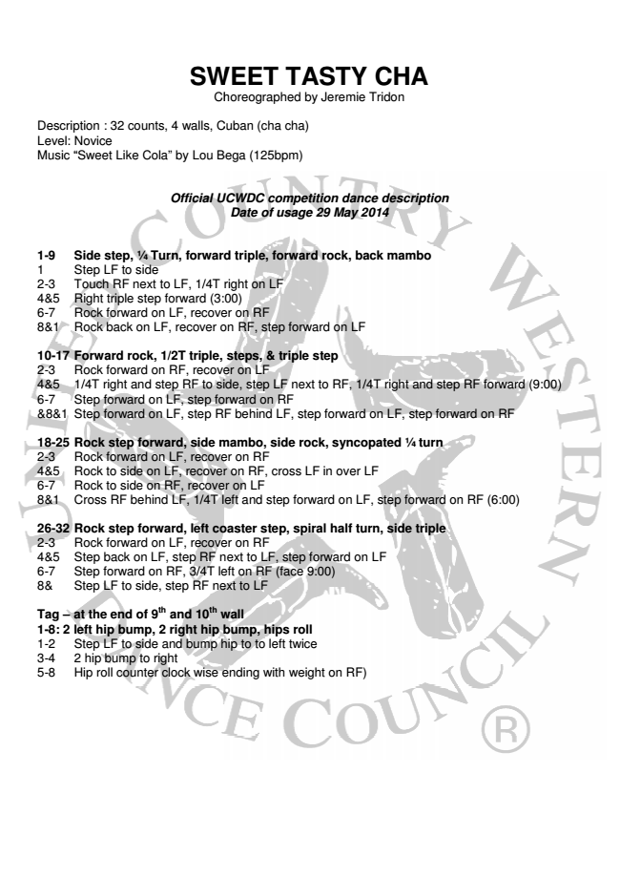
SWEET SWEET TASTY TAST
CHA Choreographed Choreograph
by Jeremie Tridon
Description : 32 counts, 4 walls, Cuban Cuban (cha (cha cha)
c Level: Novice Music “Sweet Like Cola” by Lou Lou Bega Bega
(125bpm)
Official Official UCWDC UCWDC competition com
dance description Date of usage 29 May 2014
1-9 Side step, 1⁄4 Turn, forward forward triple, triple, forward for
rock, back mambo 1 Step LF to side 2-3 Touch RF next to o LF, LF, 1/4T 1/4T right right on on LF LF 4&5 Right triple step forward forward (3:00) (3:00) 6-7 Rock forward on LF, LF, recover recover on on RF RF 8&1 Rock back on LF, , recover recover on on RF, RF, step step
forward on LF
10-17 Forward rock, 1/2T triple, triple, steps, steps, & & triple tr
step 2-3 Rock forward on RF, RF, recover recover on on LF LF 4&5 1/4T right and step tep RF RF to to side, side, step step LF LF
next to RF, 1/4T right and step RF forwa 6-7 Step forward on LF, LF, step step forward forward on on RF RF &8&1 Step forward on LF, step step RF RF behind behind LF, LF
step forward on LF, step forward on RF
18-25 Rock step forward, , side side mambo, mambo, side sid
rock, syncopated 1⁄4 turn 2-3 Rock forward on LF, LF, recover recover on on RF RF 4&5 Rock to side on LF, recover recover on on RF, RF, cross cro
LF in over LF 6-7 Rock to side on RF, recover cover on on LF LF 8&1 Cross RF behind d LF, LF, 1/4T 1/4T left left and and step step
forward on LF, step forward on RF
26-32 Rock step forward, left coaster coaster step, step,
spiral half turn, side triple 2-3 Rock forward on LF, LF, recover recover on on RF RF 4&5 Step back on LF, , step step RF RF next next to to LF, LF, step s
forward on LF 6-7 Step forward on RF, RF, 3/4T 3/4T left left on on RF RF (face (fa
9:00) 8& Step LF to side, step step RF RF next next to to LF LF
Tag – at the end of 9
th
and 10
th
wall wall 1-8: 2 left hip bump, 2 right right hip hip bump, bump, hips hips
roll 1-2 Step LF to side and and bump bump hip hip to to to to left left
twice 3-4 2 hip bump to right 5-8 Hip roll counter clock wise ending ending with with
weight on RF)
escription
ight and step RF forward (9:00)
LF, step forward on RF
ep forward on RF (6:00)

